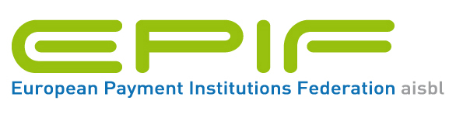

For Immediate Release
20 June 2012

EPIF 1st Anniversary News Release
One year on after its foundation, the European Payment Institutions Federation (EPIF) now has a total of 18 members and is continuing to grow as it looks to engage with EU institutions on a number of policy and regulatory issues.
Founded by a number of its members, it is focused on ensuring the representation of payment institutions (PIs), who have come under a European regulatory regime with the Payments Services Directive in November 2009. PIs represent a range of non-bank payment providers: certain card providers and acquirers, money remittance, mobile payments, processing and foreign exchange trading.
Sarah Sheehan, chair of the Board of EPIF said, “In little over a year we have successfully brough together PIs to address the range of policies and regulations that we as an industry now face. In the near future there are a number of issues to address, including the review of the PSD, the 4th Anti-Money Laundering Directive, SEPA Governance to list but a few”.
The first General Meeting of EPIF is being held on 20 June, 2012, in Brussels, followed by its Annual Reception at Rue de la Science 14b. Guest speakers at the reception are: Sempo Terho, MEP and Jean-Yves Muylle, European Commission.
The meeting will also confirm its commitment to appoint Afore Consulting as the Secretariat of EPIF.

